**Noise pollution monitoring**

**Data collection and Iot devices**

Creating an IoT-based noise pollution monitoring system involves deploying sensor nodes in key locations to collect data.

These devices measure sound levels, and the data can be transmitted to a central server for analysis.

**Data processing and analysis**

IoT-based noise pollution monitoring involves collecting data from sensors, processing it for relevant information, and analyzing patterns to understand noise levels. It simplifies tracking and managing noise pollution for better environmental insights.

**Web development**

Creating a website to monitor noise pollution using IoT involves connecting sensors to measure noise levels and then displaying that data on a user-friendly website for easy access and analysis.

**User interface**

Designing an intuitive dashboard with real-time noise data, customizable settings, and visual alerts can simplify the IoT-based noise pollution monitoring user interface.

**Data visualization**

IoT-based noise pollution monitoring data visualization, consider using clear graphs or charts to represent noise levels over time. Use color-coding for different noise intensity levels, and provide a user-friendly interface for easy interpretation.

**Alerts and notification**

Sensors placed around the city to detect noise levels. These sensors send real-time data to a central system. If noise surpasses a predefined limit, the system triggers alerts and notifications, keeping everyone informed about noise pollution levels instantly.

**Remote monitoring**

IoT-based noise pollution monitoring system allows for remote tracking of noise levels. It simplifies data collection and analysis, providing real-time insights for better environmental management.

**User authentication and security**

Implement robust user authentication methods such as multi-factor authentication (MFA) and use secure communication protocols like HTTPS to encrypt data transmissions.

**Database management**

Database stores and organizes the information for analysis and reporting. It helps track noise levels over time, identify patterns, and make informed decisions for managing noise pollution.

**Testing and quality assurance**

Testing and quality assurance, focus on systematic sensor calibration, data accuracy validation, and regular software updates to ensure reliable performance.

**Mobile app integration**

IoT-based noise pollution monitoring app integration, focus on clear API documentation, ensure compatibility with common platforms, and streamline user interface for easy navigation.

**Python program for connecting mobile app with noise pollution monitoring iot project :**

**From flask import Flask, request, jsonify**

**App = Flask(__name__)**

**# Dummy data for noise level, replace with actual sensor data**

**Noise_level = 0**

**@app.route(‘/get_noise_level’, methods=[‘GET’])**

**Def get_noise_level():**

**Global noise_level**

**Return jsonify({‘noise_level’: noise_level})**

**@app.route(‘/update_noise_level’, methods=[‘POST’])**

**Def update_noise_level():**

**Global noise_level**

**Data = request.get_json()**

**Noise_level = data.get(‘noise_level’)**

**Return jsonify({‘message’: ‘Noise level updated successfully’})**

**If __name__ == ‘__main__’:**

**App.run(debug=True)**

Python and Flask for a basic connection between a mobile app and a noise pollution monitoring IoT project.

In your mobile app, you would then make HTTP requests to the provided endpoints (e.g., /get_noise_level to retrieve data, and /update_noise_level to send data).

**Testing and debugging**

Create a streamlined UI for your noise pollution monitoring app, focus on real-time data visualization, and ensure IoT device connectivity is robust for effective testing and debugging.

**Deployment**

Mobile devices involves deploying sensors in strategic locations. These sensors collect data on noise levels, which is then transmitted to a central server for analysis. Mobile connectivity ensures real-time monitoring and data updates.

**Connecting mobile app with noise pollution monitoring iot project**

**IoT Device Setup:**

Set up your noise monitoring IoT device with sensors to measure noise levels.

**Hardware Setup:**

Use a noise sensor (like a sound sensor) with Arduino to measure noise levels.

Connect the sensor to Arduino according to its datasheet.

Connect Arduino to an IoT module (e.g., ESP8266, ESP32) for internet connectivity.

**Programming Arduino:**

Write a program for Arduino to read data from the noise sensor.

Use the IoT module to send this data to a cloud server. You might use platforms like ThingSpeak, Blynk, or others.

**Cloud Setup:**

Create an account on a cloud platform that supports IoT data storage (e.g., ThingSpeak, Firebase).

Set up a new project and obtain the required credentials (API key, project ID, etc.).

**Mobile App Development:**

Develop a mobile app (iOS/Android) using a framework like React Native, Flutter, or native development.

Implement features to fetch data from the cloud server using APIs provided by the IoT platform.

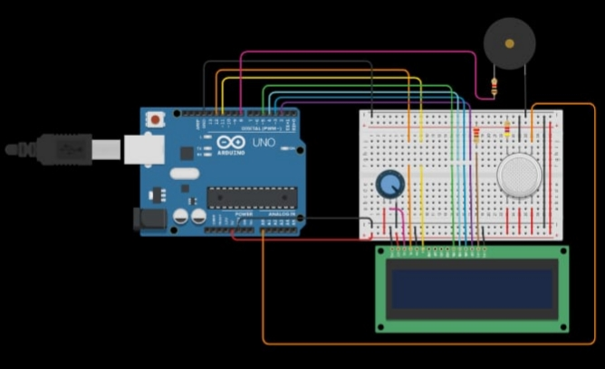Circuit diagram for noise pollution monitoring

3D representation for Noise pollution monitoring

